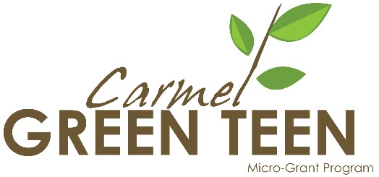
Tips on Applying for Awards
As outlined in “Why Apply for Awards,” winning awards and recognition can be vital to your program’s continued positive reputation, publicity, and funding sources. Here are some tips on how to maximize your chances of receiving an award for which you apply.
Find a good fit. Because there are so many local, state, national, and international forms of awards, recognition, and scholarship available to you, there is little reason to apply for an award that does not align with your program’s mission. Here’s a good rule of thumb: if you read through the award description and criteria and think that the award judges would be confused as to why you applied or not be excited about your program, don’t waste your time applying. If you can imagine the awarders getting excited about your program, go ahead and apply.
Use key words. When reading through an award description or award criteria, take note of the words that are used over and over again. Do the awarders seem to use the word “sustainability” instead of “conservation?” If so, consider using the word that they prefer in your own award application. Judges will then see your program as more in line with their own mission, which will increase your chances of getting the award.
Check about supplementals. Awards often ask a very specific set of questions or request only certain materials, which can leave out important and relevant information that you might wish to share with the judges. If this is the case, you may ask whether you may send a small amount of additional information you think most pertinent. Don’t overwhelm the judges, though. If supplemental materials are accepted, minimize what you send while still representing your program fully.
Don’t forget to be human. When getting into the groove of answering award application questions, it is all too easy to provide only facts and numbers about your program. While calculations are vital to showing your program’s impact, just as vital are the stories you share about the impacts on human lives. Did your award recipients say something wonderful to you about the environment? Did you see them grow? Did you yourself grow or feel something meaningful as a result of the program? If so, share!
Apply frequently. It is a wonderful feeling to win an award that gives your board members and grant awardees much-deserved recognition for all of their hard work, and it is easy to feel content for a while after winning such an award. However, it is important to have a steady stream of fresh awards so that your program has continued credibility. For example, a funder might be nervous seeing that your program has not earned any recognition for two years.
Don’t give up! After spending hours on an award application, getting a rejection email can be discouraging. Getting rejection is just part of the process of learning about how to apply for awards and how to best present your program to others. Our Carmel Green Teen Micro-Grant Program has been rejected for more awards than I care to remember, but it continues to live on as a reputable program. Remember, nobody sees your award rejections besides you. Pick yourself up, brush yourself off, and either apply again next year or seek out a new award.

