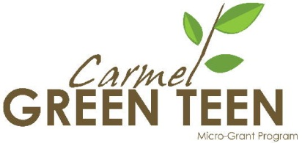
SCREENING CHECKLIST
- 1 2 3 4 5 +
Initials ____
Date _______

Project #1

P
Project #5
Project #4
Project #3
Project #2

 | (Title here)  Req: $____________ | Req: $_____________ | Req: $____________ | Req: $____________ | Req” $____________
- Degree of environmental impact: Does it reduce pollution, conserve natural resources, and/or save energy?

- Degree of youth direction in planning and management.

- Educational value for youth implementing the project and for the community.

- Creative problem-solving.

- Variety of roles/responsibilities for volunteers.

- Appropriateness of budget for services.

- Value for the dollar.

TOTAL SCORE:
(Add numbers in boxes)

I had a positive/negative impression of this project. (Circle one) | + -  Why: | + -  Why: | + -  Why: | + -  Why: | + -  Why:
Recommendation:  Full amount  Adjusted amount (suggest amt.)  Do not recommend | $_____________ | $_____________ | $_____________ | $_____________ | $_____________

