We are indebted to the greater Carmel community and to the following non-profit organizations for their dedication to youth service and environmental stewardship. Thank you for your continued support!
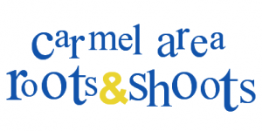

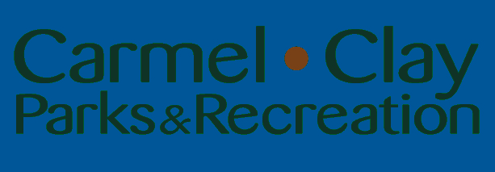
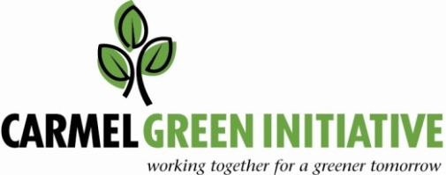

Special thanks to our adult board members Colleen Beeler, Monica Cannaley, Margot Gibson, Marcia Roberts, Elizabeth Roe, Becky Schmiesing, Paula Shepley, Kelly Stemnock, Julie Williams and Joe Zinkan

Award Presentation Ceremony
March 21, 2012 – 4:00 PM
City of Carmel Gazebo
(north side of City Hall)

Thanks also to our generous local food sponsors for their commitment to the Carmel youth community by donating delicious, wholesome treats for our awards ceremony today.

Making Carmel greener, one youth project at a time.

