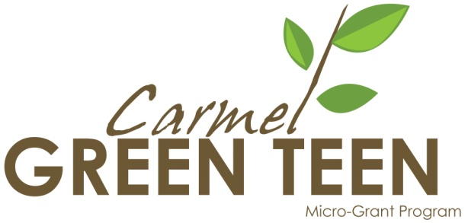

PROJECT CONTRACT
Grant Cycle - Spring 2012

THIS AGREEMENT IS BETWEEN:
Carmel Green Teen Micro-Grant Program
a project of Youth as Resources/United Way of Central Indiana Contact: Lauren Gibson
13810 Laredo Drive
Carmel, IN 46032 (317) 571-9536

PROJECT NAME: ________________________________________________________________

SPONSORING AGENCY: __________________________________________________________

ADDRESS: _____________________________________________________________________

ADULT CONTACT: ________________________________________________________________

THE PARTICIPANTS AGREE:

- We will use the grant money as outlined in our grant application to perform the green youth project in Carmel/Clay Township, Indiana, within 6 months of receiving the award. Any unused funds over $30 will be returned to the Carmel Green Teen Micro-Grant Program within this time frame.

- We will notify the Carmel Green Micro-Grant Program as to the exact date(s) our project will take place at least two week’s prior to the event.

- We understand that community education and outreach are key components of our project. With the help of the Carmel Green Micro-Grant Program press release template and press list, (or via other methods,) we will publicize our project. We will notify the Carmel Green Teen Micro-Grant Program of any publicity our project receives, including sending copies or links of all publicity via email to: admin@carmelgreenteen.org

PROJECT CONTRACT - continued

- To inspire and motivate our community, we will provide photos and details of our project to be used for our project’s CarmelGreenTeen.org web page and for the press.

- We will work with the Carmel Green Micro-Grant Program to determine the environmental impact of our project, as well as keep data on:
- the number of youth and adults participating in the project
- the number and description of other agencies/organizations involved with our green youth project
- the number of people served by the project
- the services provided by youth volunteers
- the community impact resulting from this project

- We will complete the provided Carmel Green Teen Micro-Grant Program Project Report Form within one month of the end of our project activities, including accurate accounting of all grant money spent.

Representing our project, we agree to all of the above:

_____________________________________________________________________
Youth Representative Phone Number

_____________________________________________________________________
Youth Representative E-Mail Address Date

`
Adult Representative Phone Number

_____________________________________________________________________
Adult Representative E-Mail Address Date

